**Functions Part 2 Parameters and Arguments**

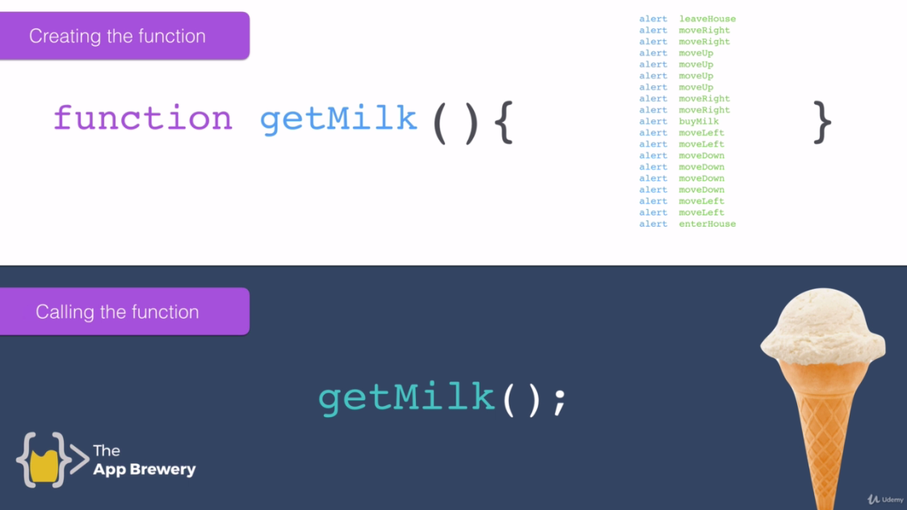

**Function Syntax:**

Function name(arguments){

//body

}

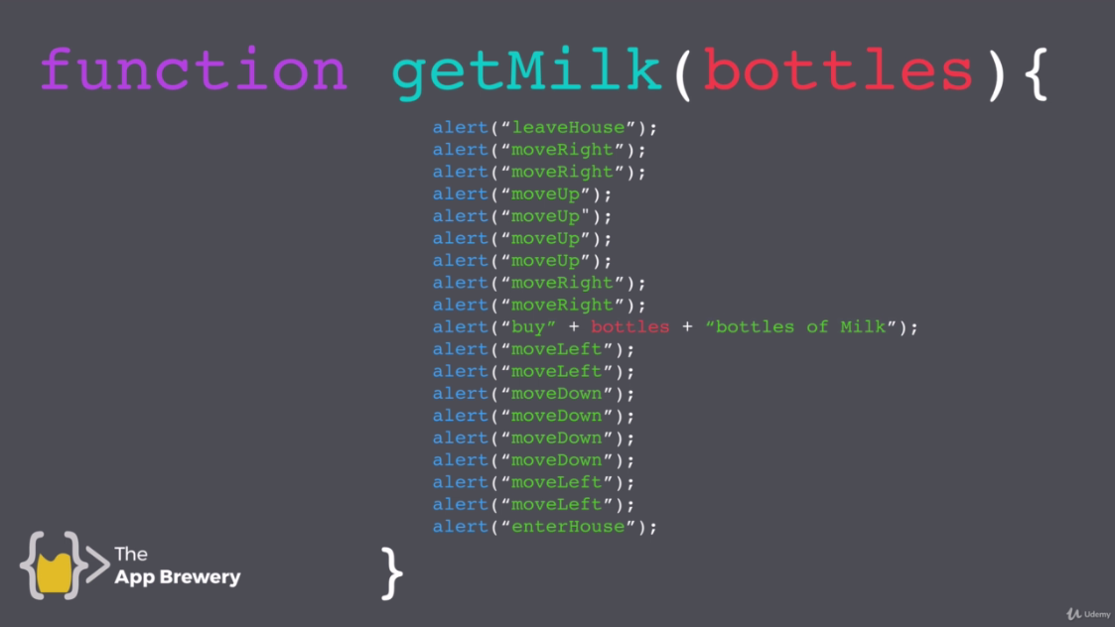

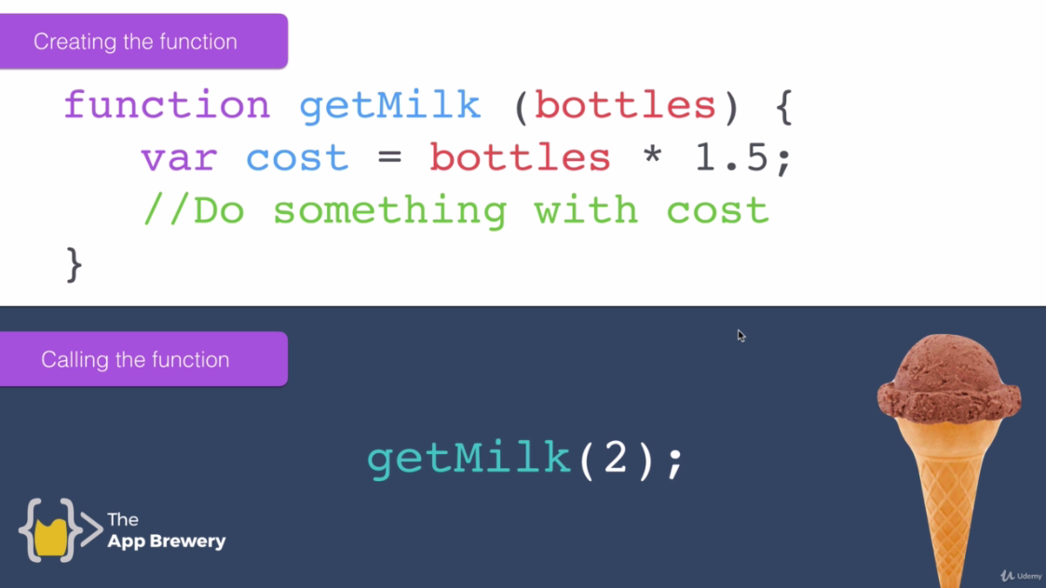

**Code1:**

function getMilk(bottles){

console.log("Leave House");

console.log("Move Right");

console.log("Move Right");

console.log("Move Up");

console.log("Move Up");

console.log("Move Up");

console.log("Move Up");

console.log("Move Right");

console.log("Move Right");

console.log("Buy "+bottles+" bottles of Milk.");

console.log("Move Left");

console.log("Move Down");

console.log("Move Down");

console.log("Move Down");

console.log("Move Down");

console.log("Move Left");

console.log("Move Left");

console.log("Enter House");

}

//Functioon call

getMilk(5);

function getMilk(money){

console.log("Leave House");

console.log("Move Right");

console.log("Move Right");

console.log("Move Up");

console.log("Move Up");

console.log("Move Up");

console.log("Move Up");

console.log("Move Right");

console.log("Move Right");

var noOfBottles = Math.floor(money/1.5); //floor function

console.log("Buy "+noOfBottles+" bottles of Milk.");

console.log("Move Left");

console.log("Move Down");

console.log("Move Down");

console.log("Move Down");

console.log("Move Down");

console.log("Move Left");

console.log("Move Left");

console.log("Enter House");

}

//Function Call

getMilk(5);

//Visit this site

**Round down JavaScript**

<http://www.w3schools.com>

<http://www.w3schools.com/jsref/jsref_floor.asp>